STEP:1 CREATE MAVEN WEBAPP

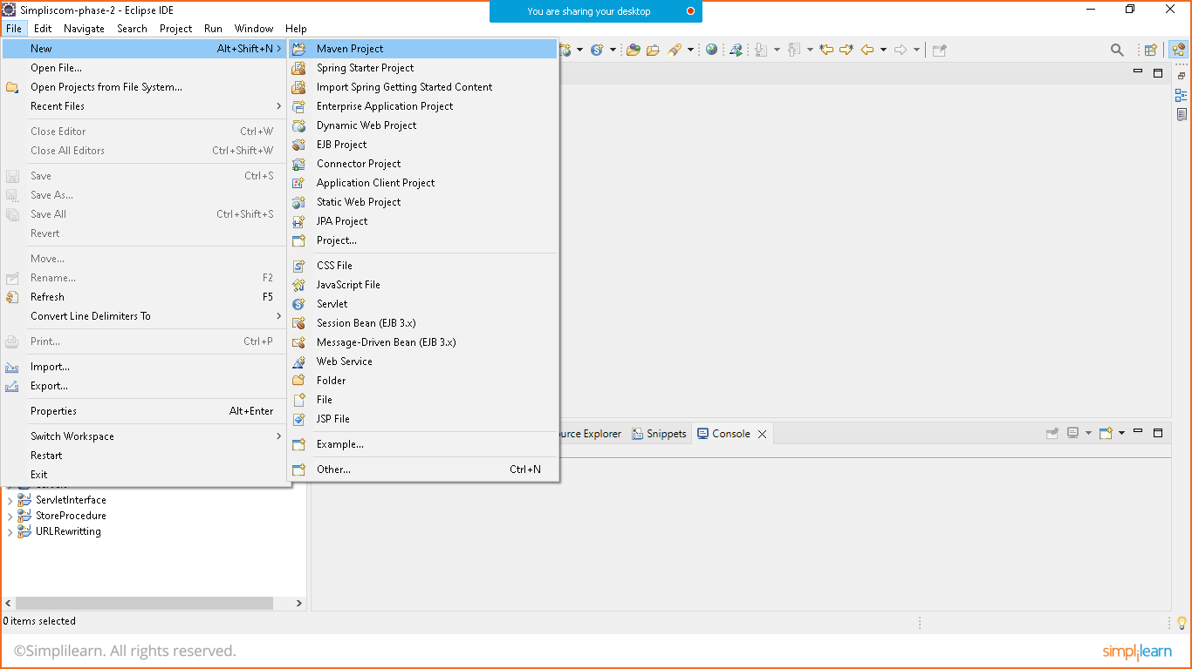

Click on next

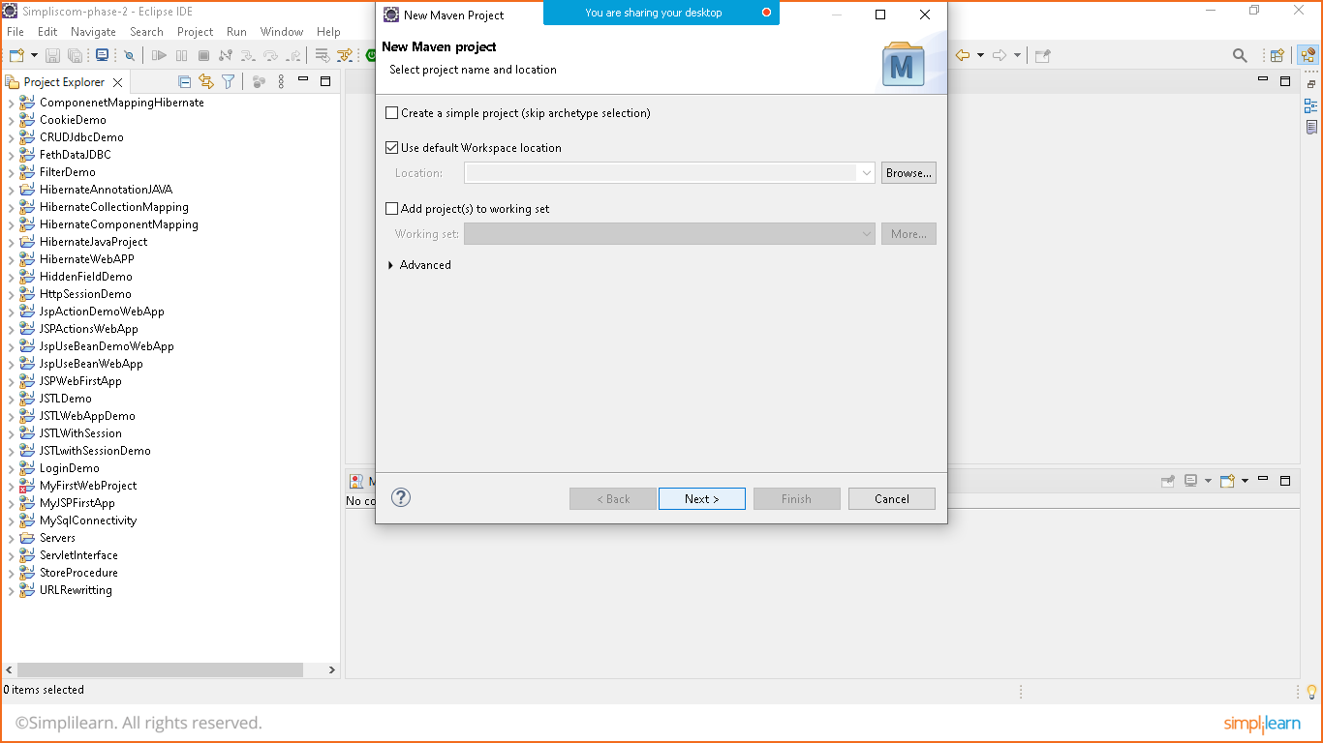

Choose web app

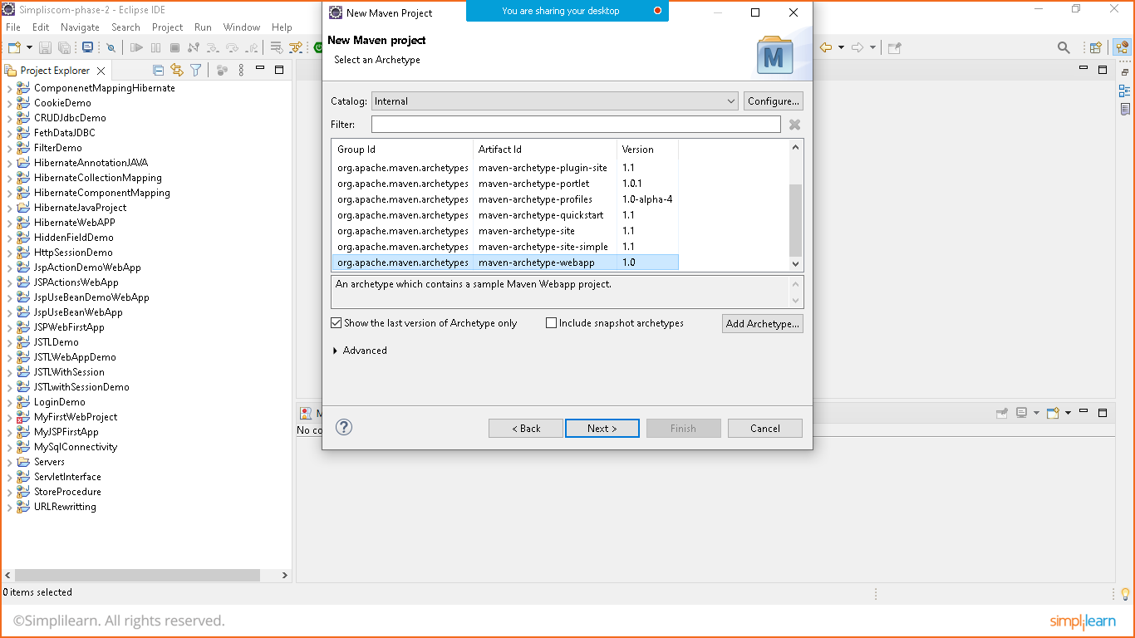

Group id and package id is same

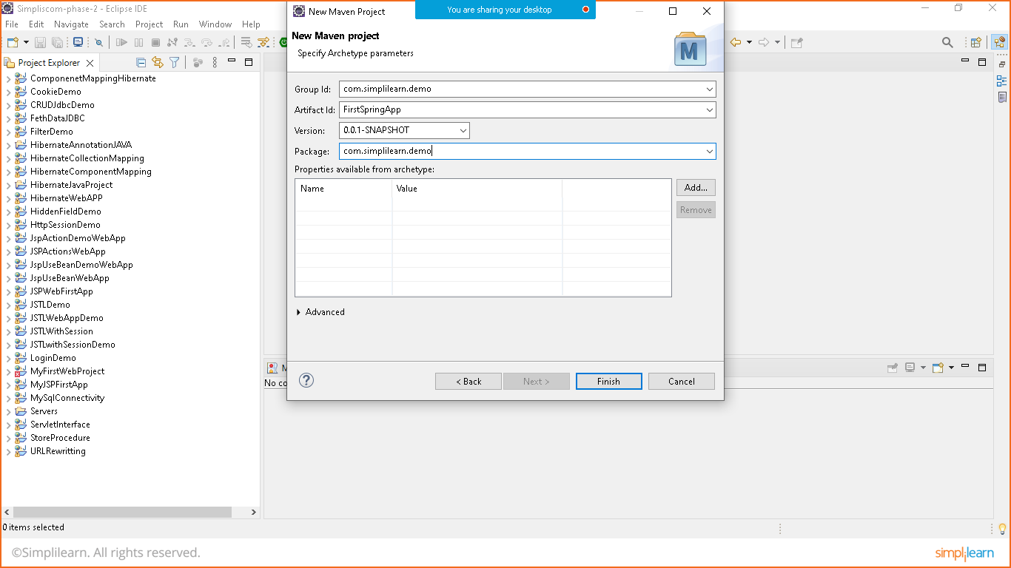

Click on finish

STEP:2 REMOVE MAVEN-WAR PLUGIN ERROR

Goto **pom.xml** file and add maven compiler plugin to remove error

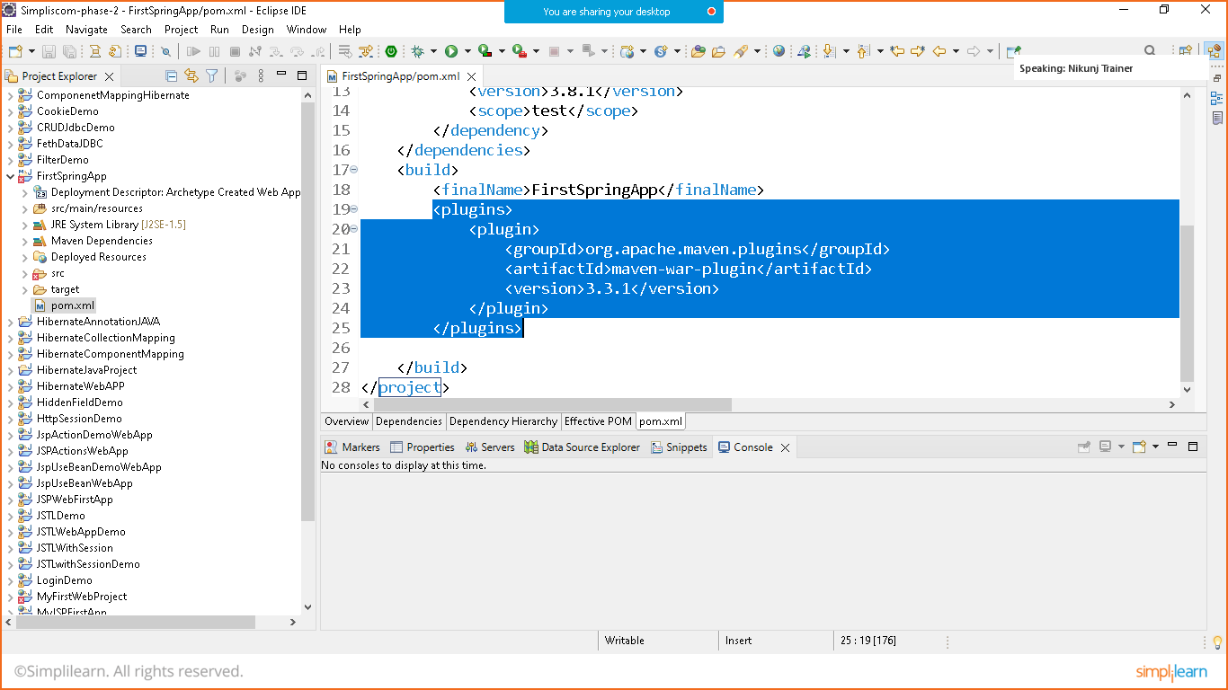

**Link: https://stackoverflow.com/questions/68397062/could-not-initialize-class-org-apache-maven-plugin-war-util-webappstructureseria**

**<plugin>**

**<groupId>org.apache.maven.plugins</groupId>**

**<artifactId>maven-war-plugin</artifactId>**

**<version>3.3.1</version>**

**</plugin>**

**<plugin>**

**<groupId>org.apache.maven.plugins</groupId>**

**<artifactId>maven-compiler-plugin</artifactId>**

**<version>3.10.1</version>**

**</plugin>**

**Press: ctr+shift+f**

Step: 3 ADD DEPENDENCY

Goto> maven repository and search for below mentioned repositories

Link: https://mvnrepository.com/

<!--SPRING CORE-->

<dependency>

<groupId>org.springframework</groupId>

<artifactId>spring-core</artifactId>

<version>5.3.22</version>

</dependency>

<!--SPRING EXPRESSION-->

<dependency>

<groupId>org.springframework</groupId>

<artifactId>spring-expression</artifactId>

<version>5.3.22</version>

</dependency>

<!--SPRING BEANS-->

<dependency>

<groupId>org.springframework</groupId>

<artifactId>spring-beans</artifactId>

<version>5.3.22</version>

</dependency>

<!--SPRING CONTEXT-->

<dependency>

<groupId>org.springframework</groupId>

<artifactId>spring-context</artifactId>

<version>5.3.22</version>

</dependency>

<!--SPRING CONTEXT SUPPORT-->

<dependency>

<groupId>org.springframework</groupId>

<artifactId>spring-context-support</artifactId>

<version>5.3.22</version>

</dependency>

<!--SPRING ORM-->

<dependency>

<groupId>org.springframework</groupId>

<artifactId>spring-orm</artifactId>

<version>5.3.22</version>

</dependency>

<!--SPRING WEB-->

<dependency>

<groupId>org.springframework</groupId>

<artifactId>spring-web</artifactId>

<version>5.3.22</version>

</dependency>

<!--SPRING WEBMVC-->

<dependency>

<groupId>org.springframework</groupId>

<artifactId>spring-webmvc</artifactId>

<version>5.3.22</version>

</dependency>

<!--JAVA SERVELET API-->

<dependency>

<groupId>javax.servlet</groupId>

<artifactId>javax.servlet-api</artifactId>

<version>4.0.1</version>

<scope>provided</scope>

</dependency>